

**System Provisioning**

**&**

**Configuration Management**

Submitted to: **Dr**. **Hitesh Kumar Sharma**

Name: **Pulkit** **Heda**

SAP ID: **500095602**

Batch: **BTech** **CSE** **DevOps**-**B3**

INDEX:

|  |  |
| --- | --- |
| Sno. | Experiment |
| 1. | Install Terraform on Windows |
| 2. | Terraform AWS Provider and IAM User Setting |
| 3. | Provisioning an EC2 Instance on AWS |
| 4. | Terraform Variables |
| 5. | Terraform Variables with Command Line Arguments |
| 6. | Terraform Multiple tfvars Files |
| 7. | Creating Multiple IAM Users in Terraform |
| 8. | Creating a VPC in Terraform |
| 9. | Creating Multiple EC2 Instances with for_each in Terraform |
| 10. | Creating an AWS RDS Instance in Terraform |

***Experiment-1***

1. Download Terraform File for Windows

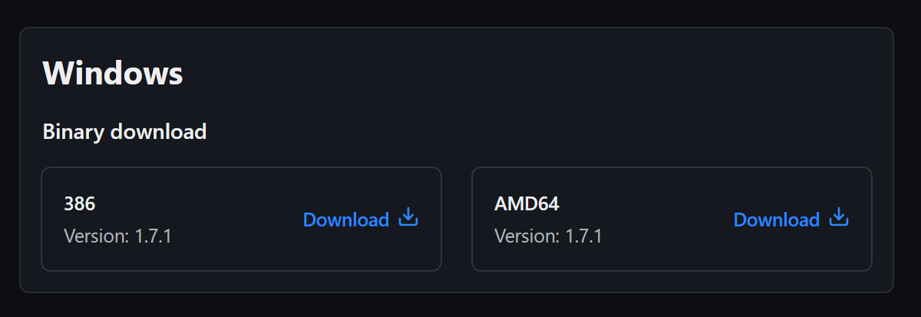

1. Add Terraform Path to System Environment Variables:

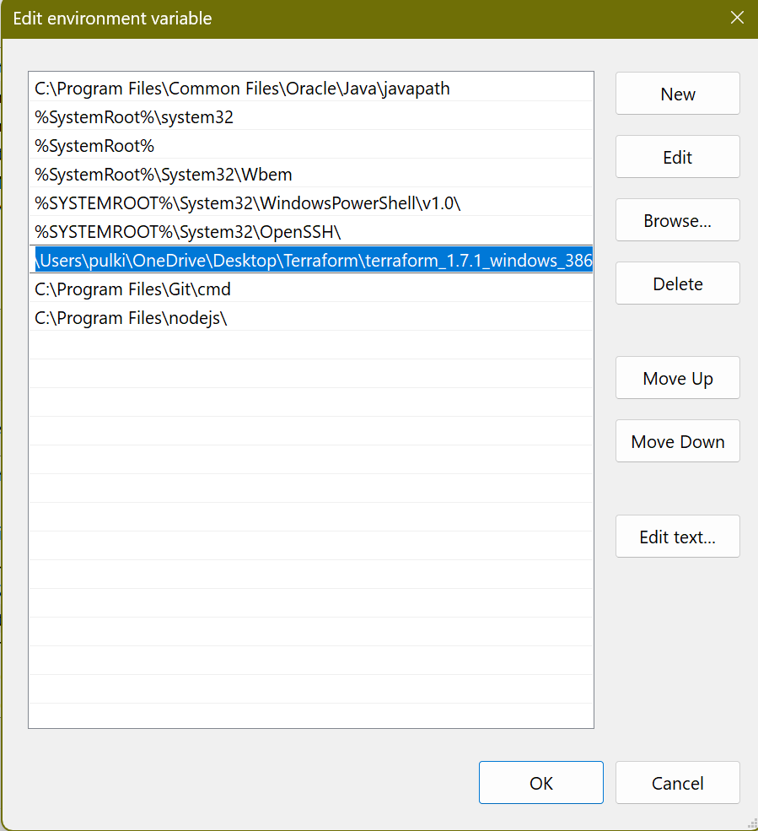

1. Verify Windows Terraform Installation:

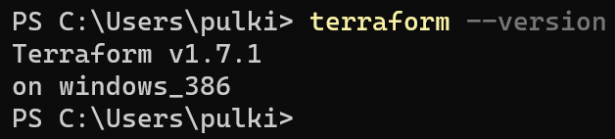

***Experiment-2***

1. Create Terraform Configuration File (main.tf):

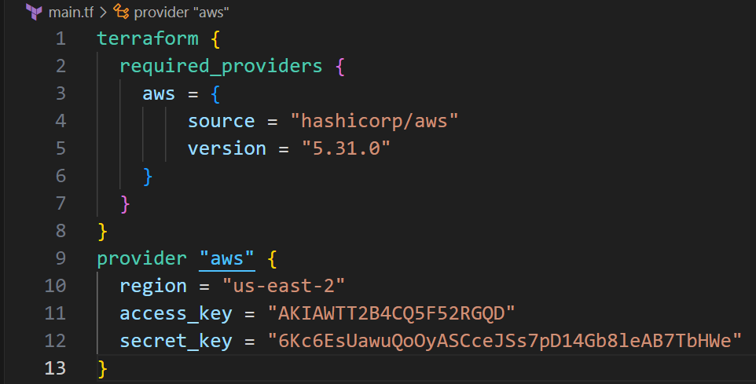

1. Initialize Terraform:

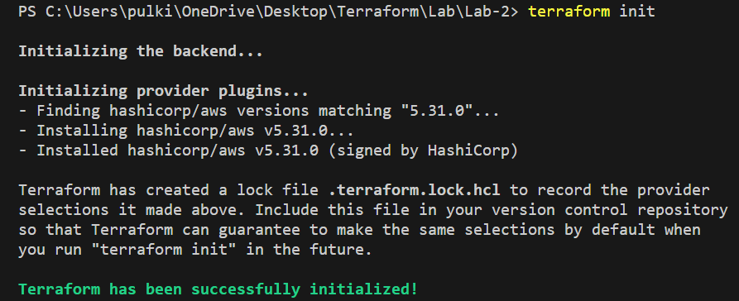

***Experiment-3***

1. Create Terraform Configuration File for EC2 instance (instance.tf):

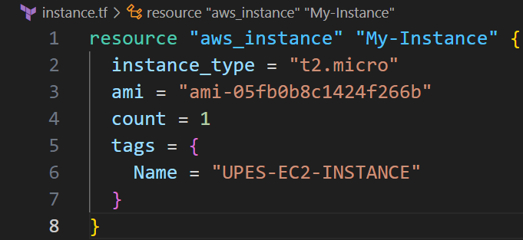

1. Review Plan:

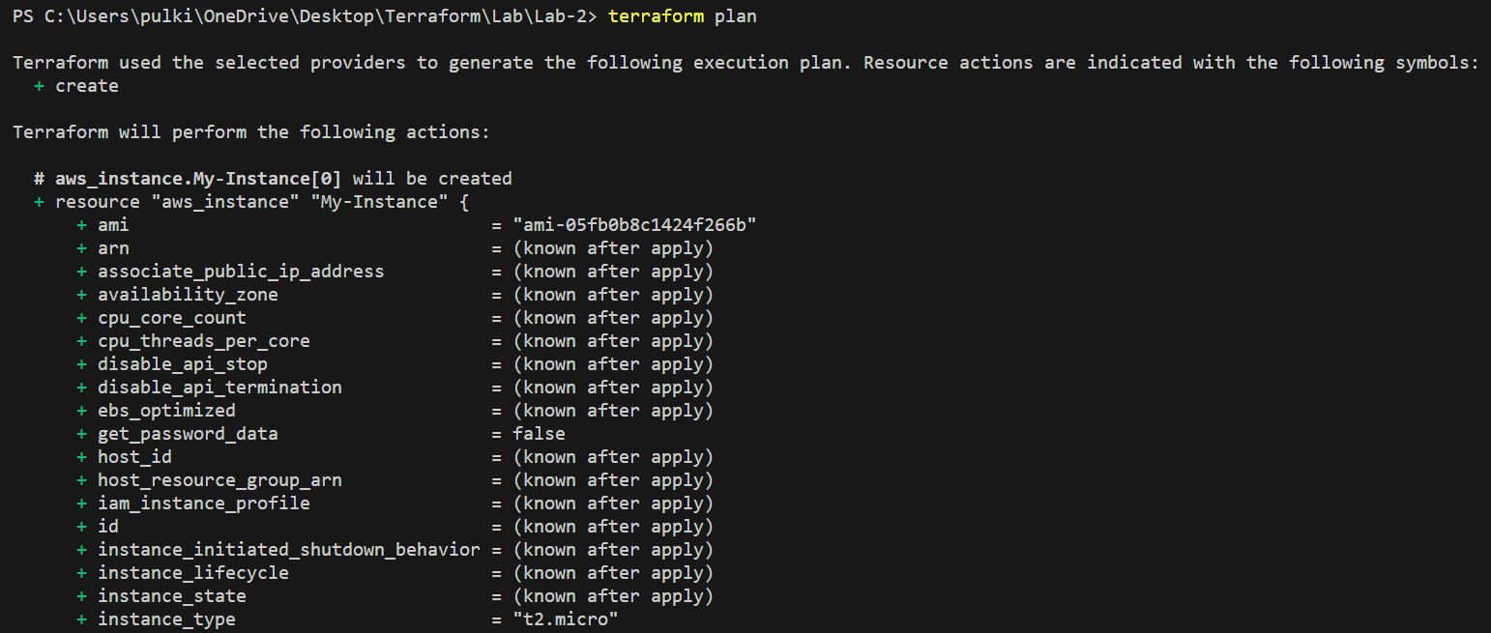

1. Apply Changes:

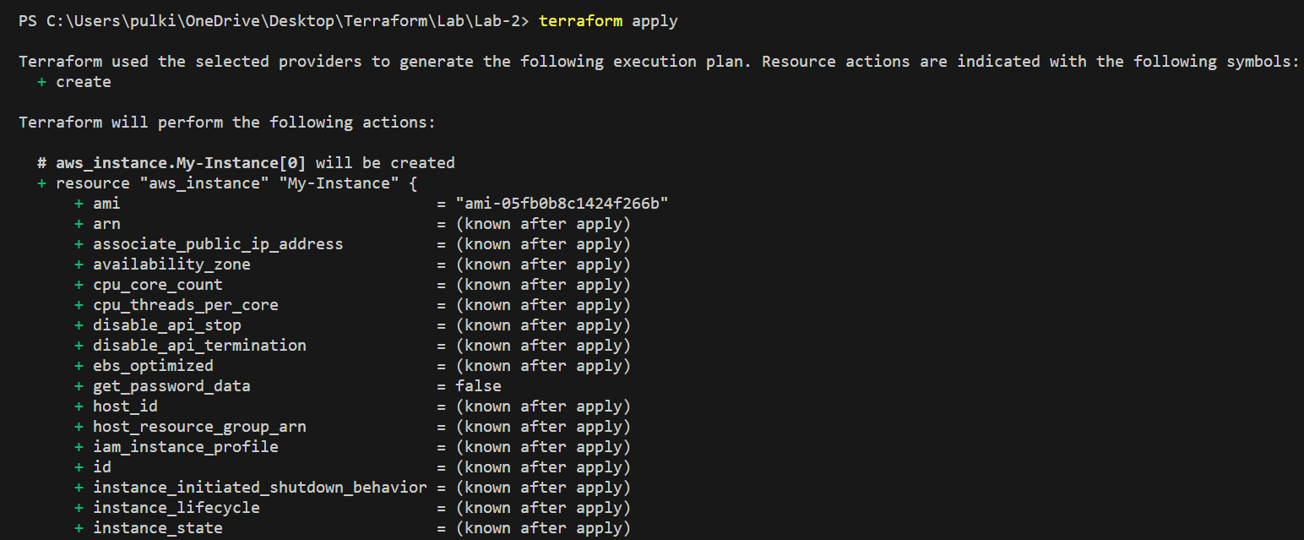

1. Verify Resources:

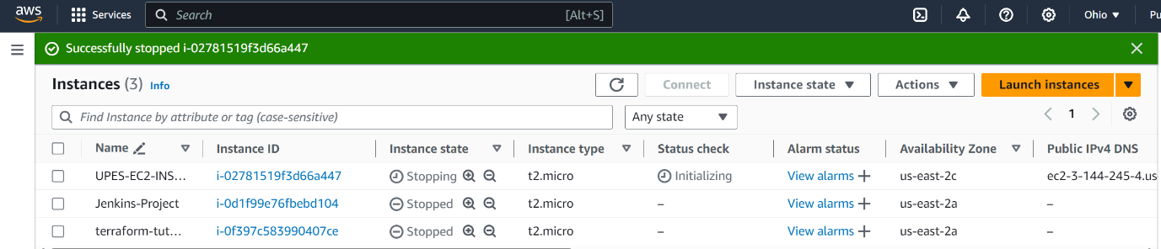

1. Cleanup Resources:

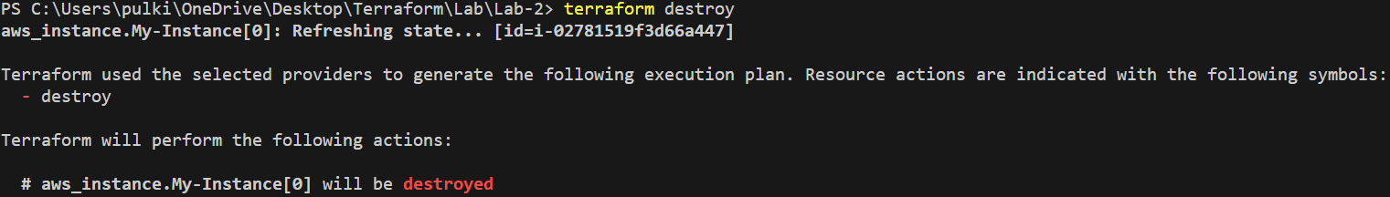

***Experiment-4***

1. Define Variables:

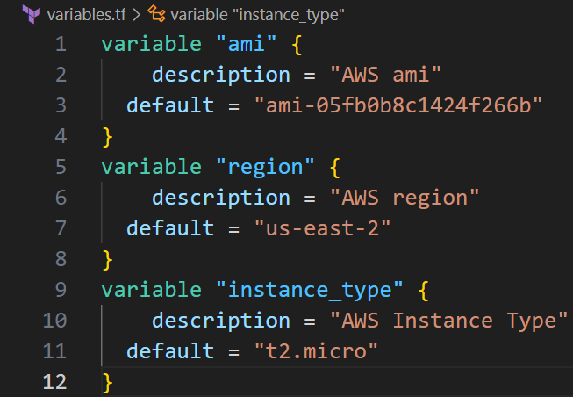

1. Use Variables in main.tf:

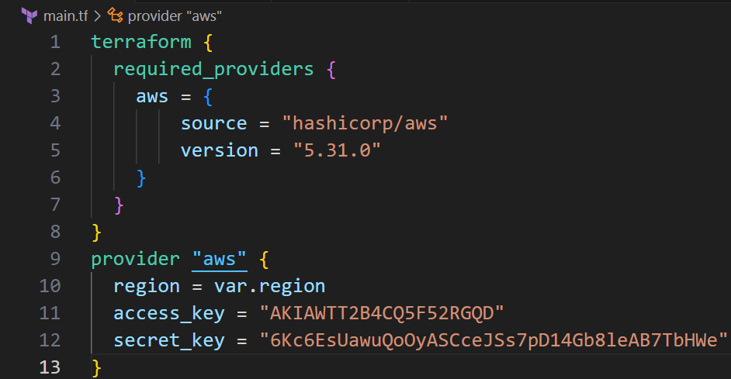

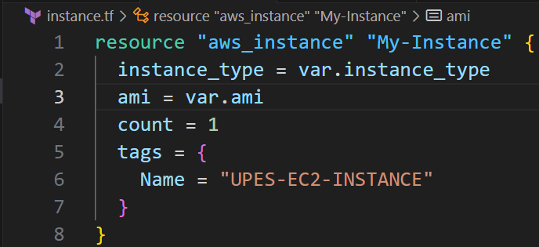

1. Initialize and Apply:

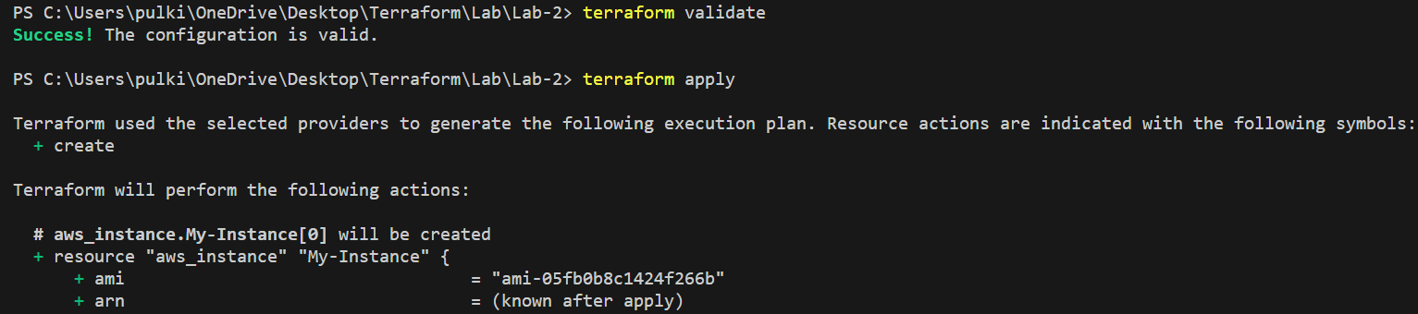

1. Verify:

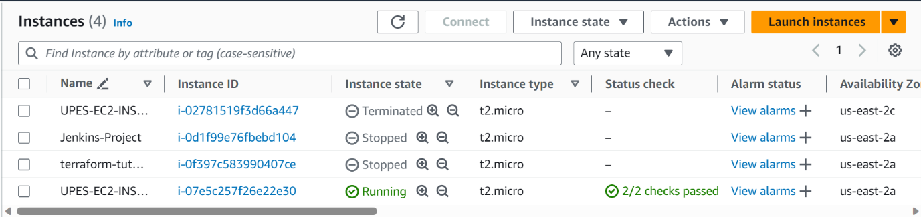

1. Clean Up:



***Experiment-5***

1. Use Command Line Arguments:

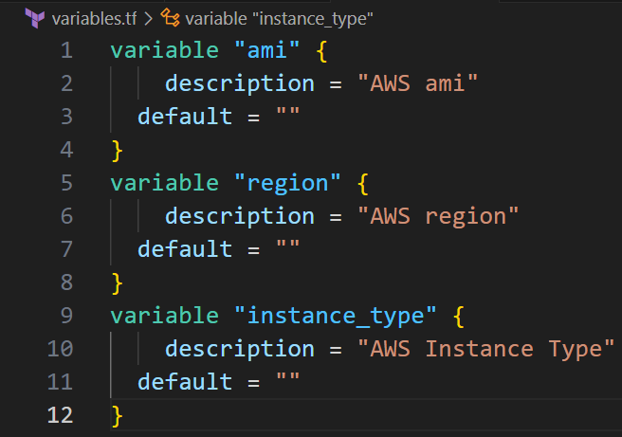

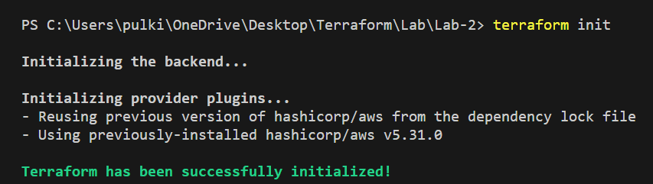

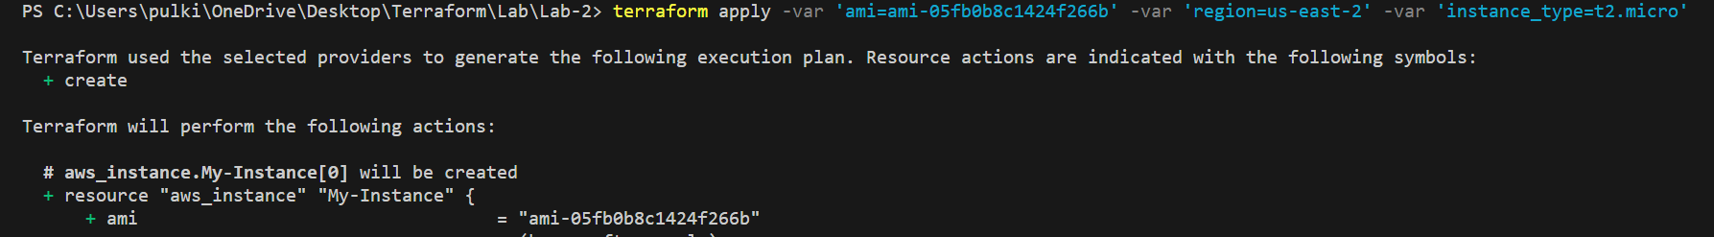

1. Test and Verify:

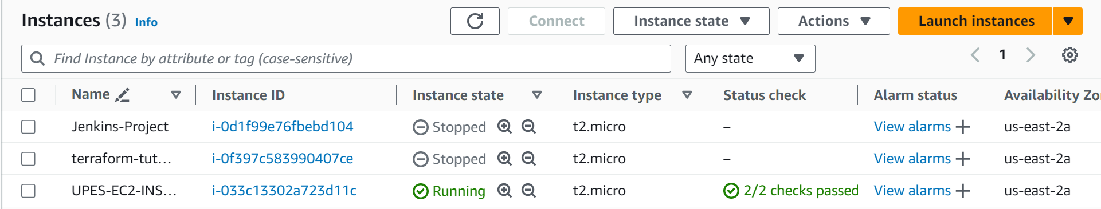

1. Clean Up:

***Experiment-6***

1. Create a Terraform Directory:

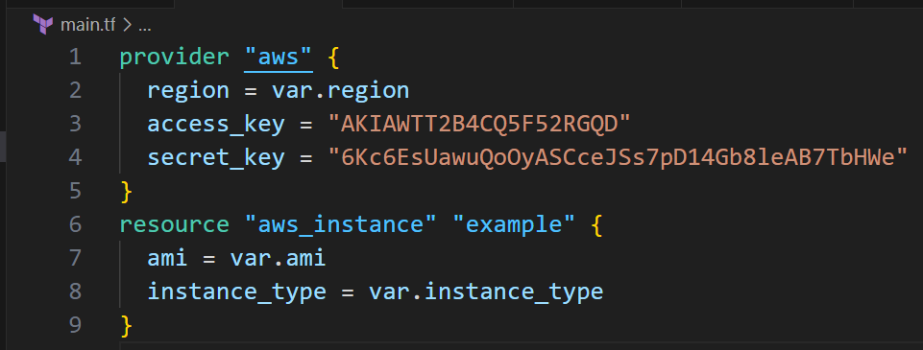

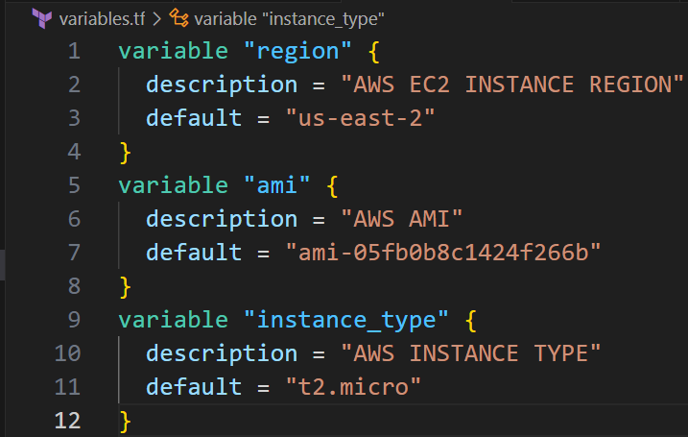

1. Create Multiple tfvars Files:

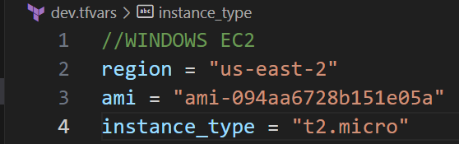

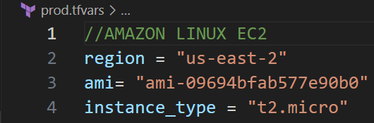

1. Initialize and Apply for Dev Environment:

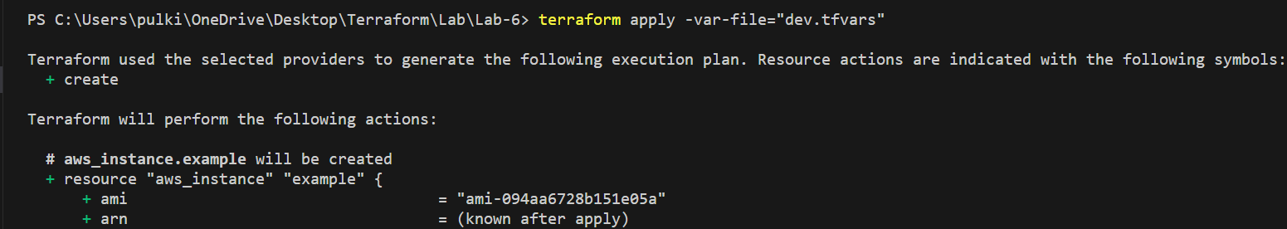

1. Initialize and Apply for Prod Environment:

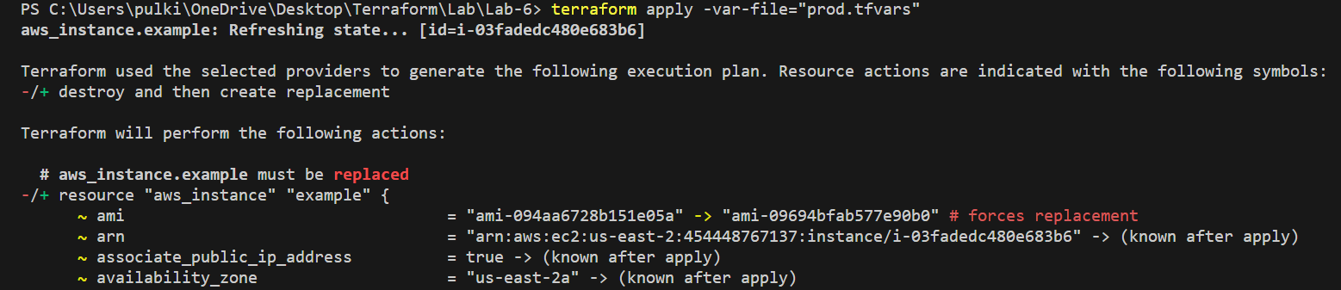

***Experiment-7***

1. Create main.tf

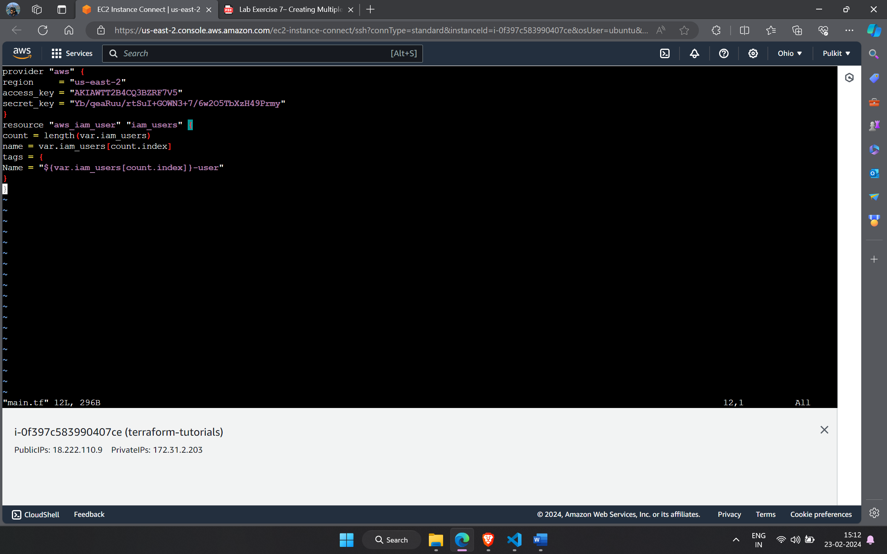

1. Create var.tf

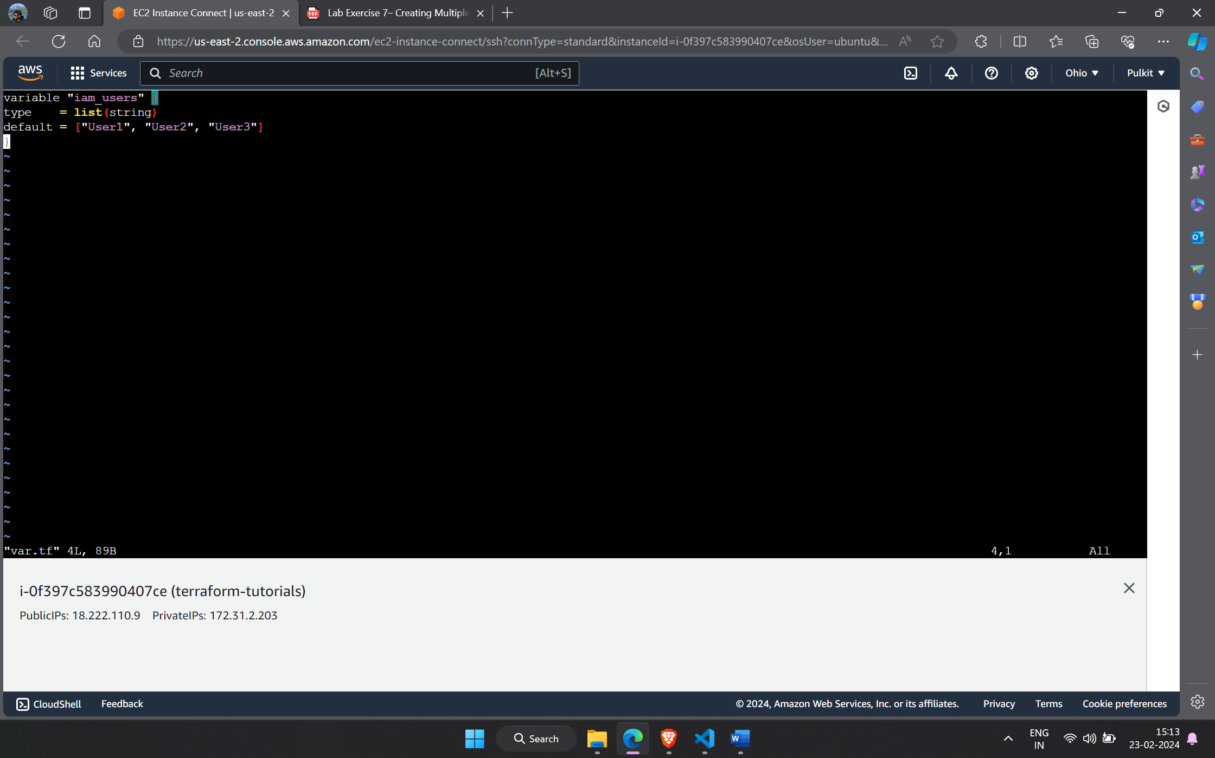

1. Terraform initialize and apply.

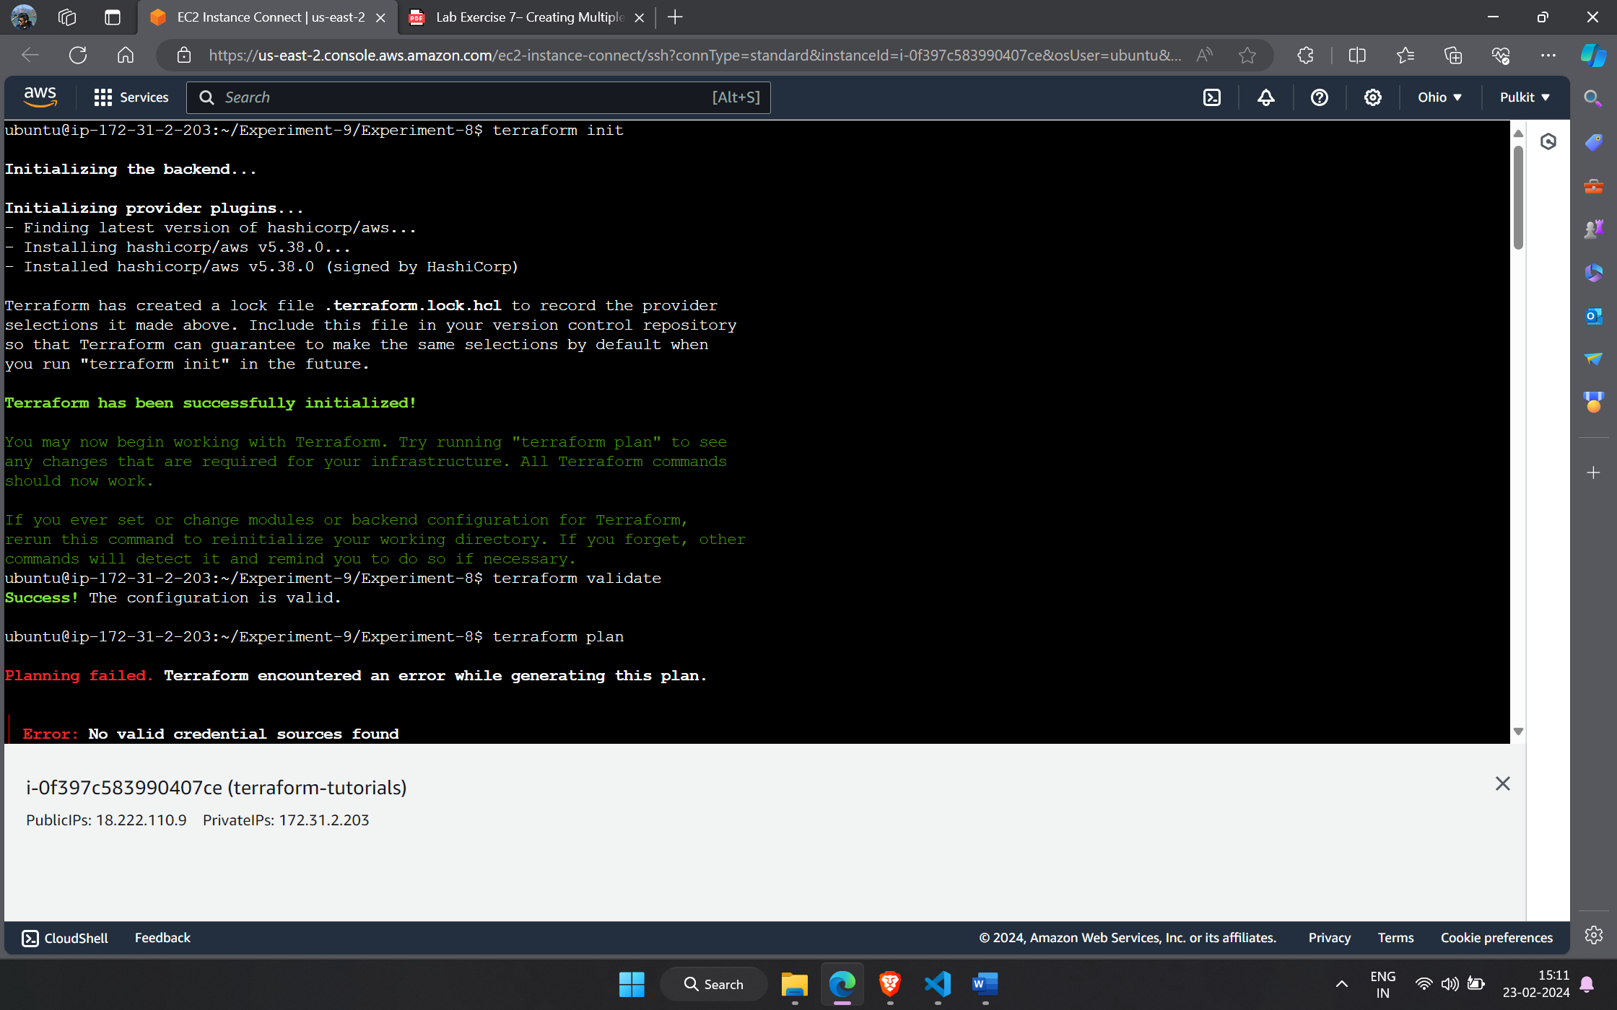

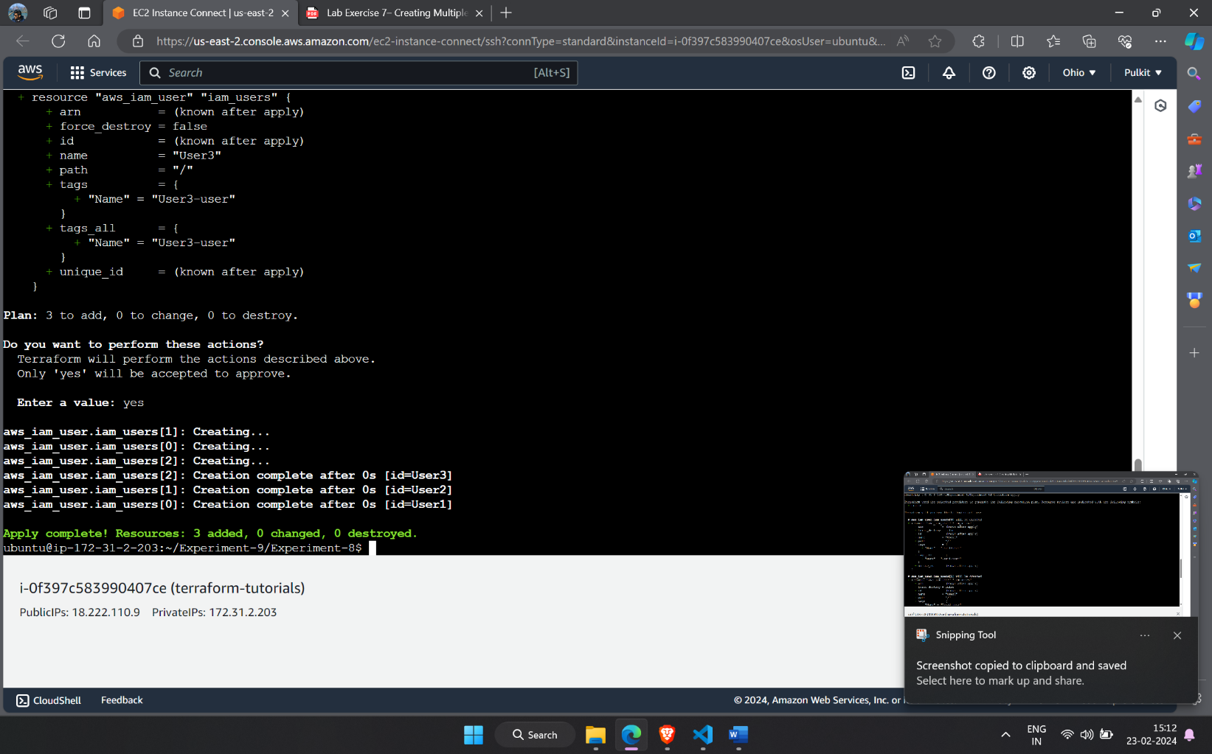

1. Verify the infrastructure.

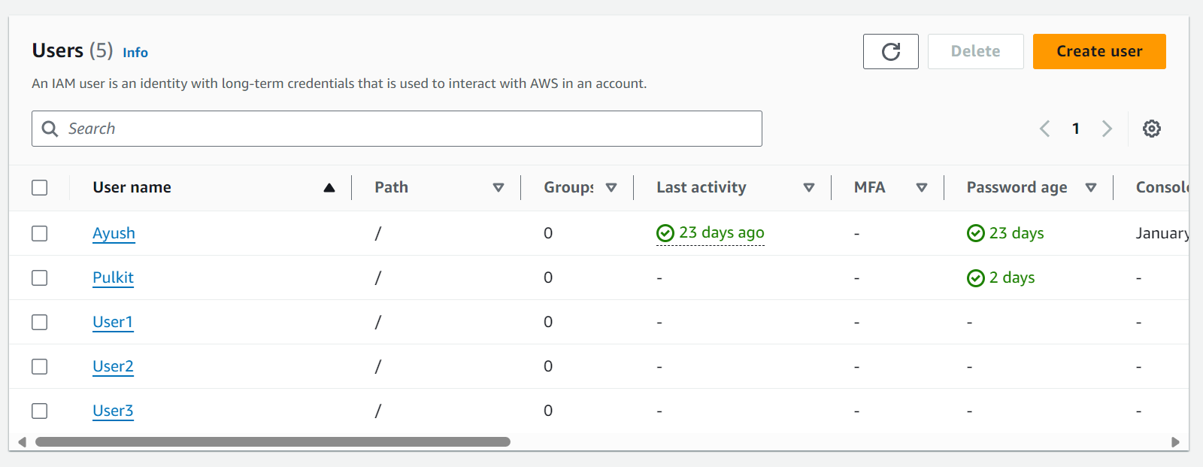

1. Destroy the infrastructure.

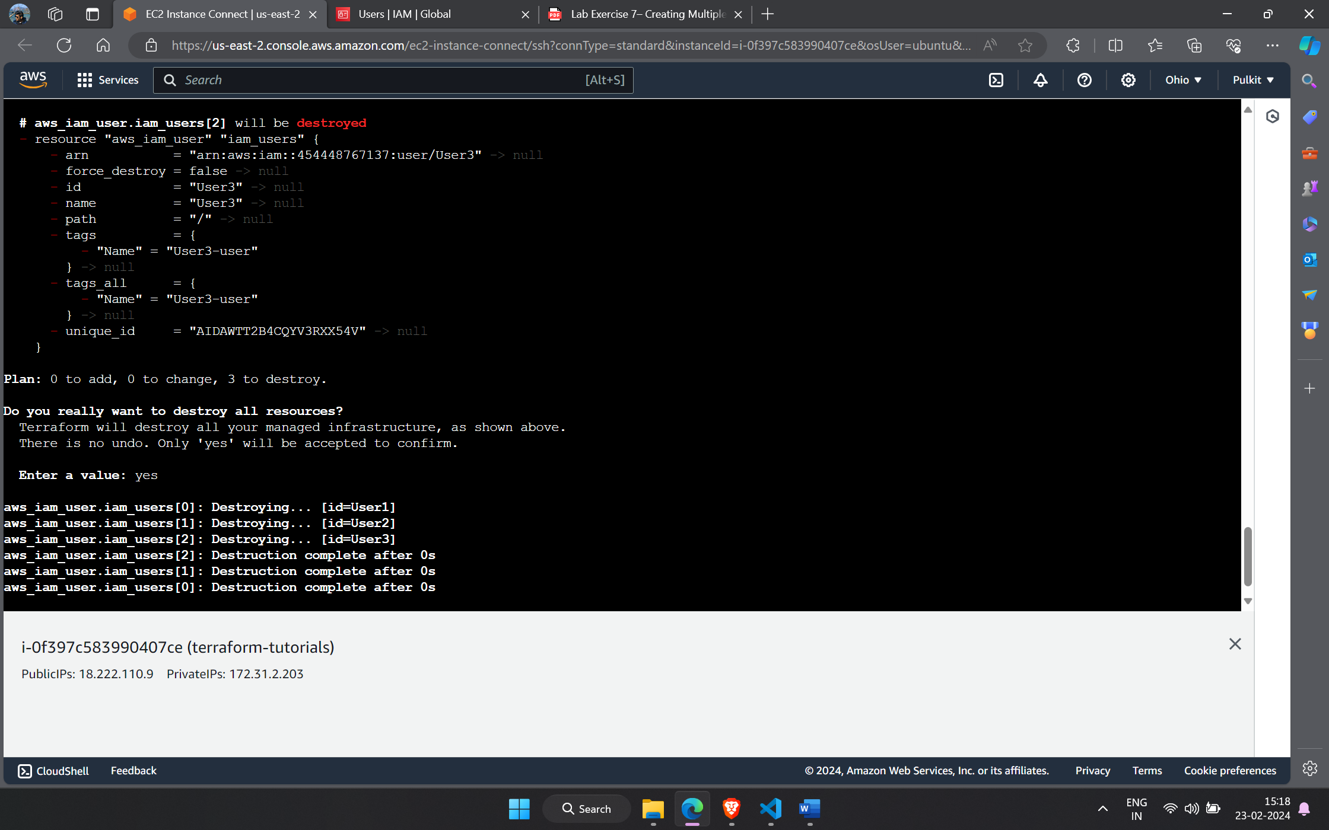

***Experiment-8***

1. Create main.tf

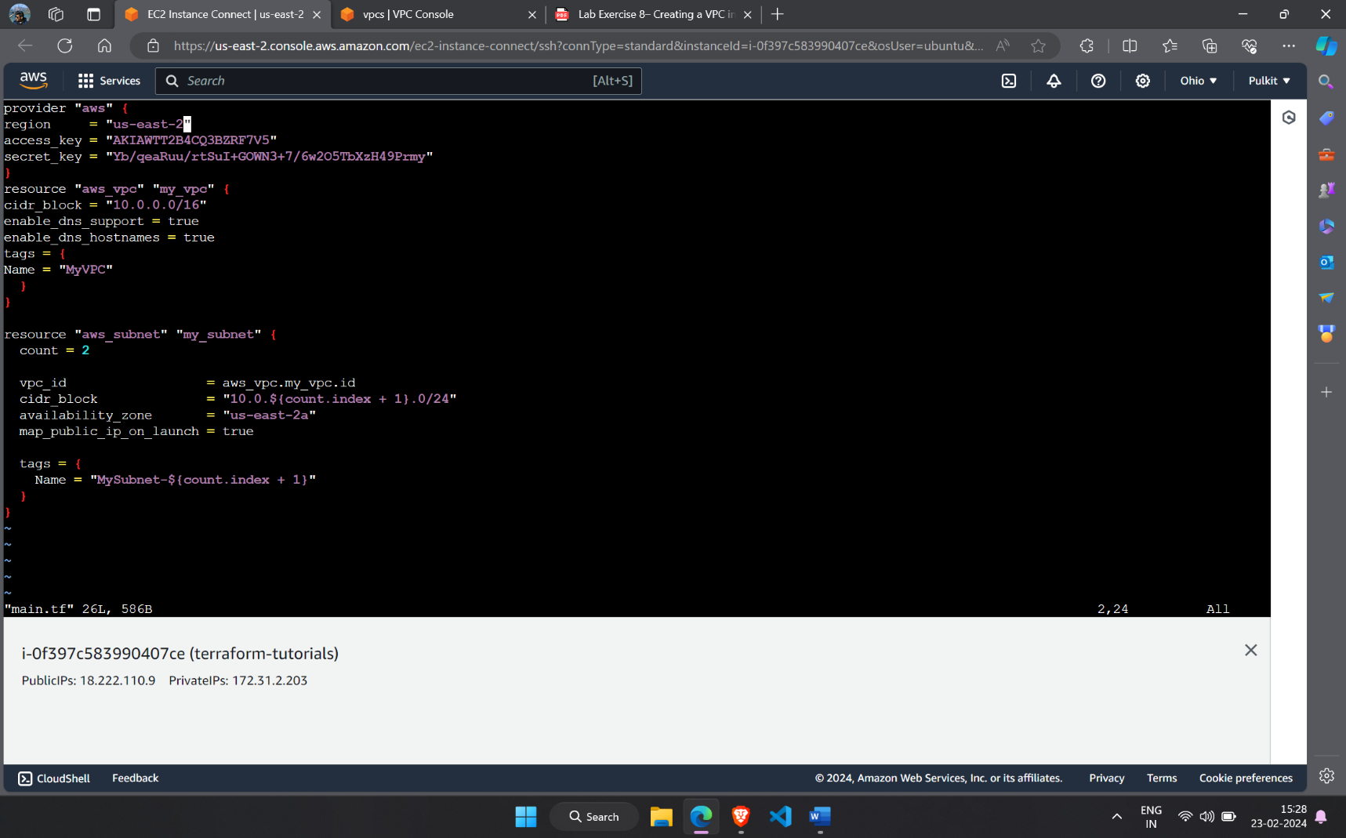

1. Terraform initialize and apply.

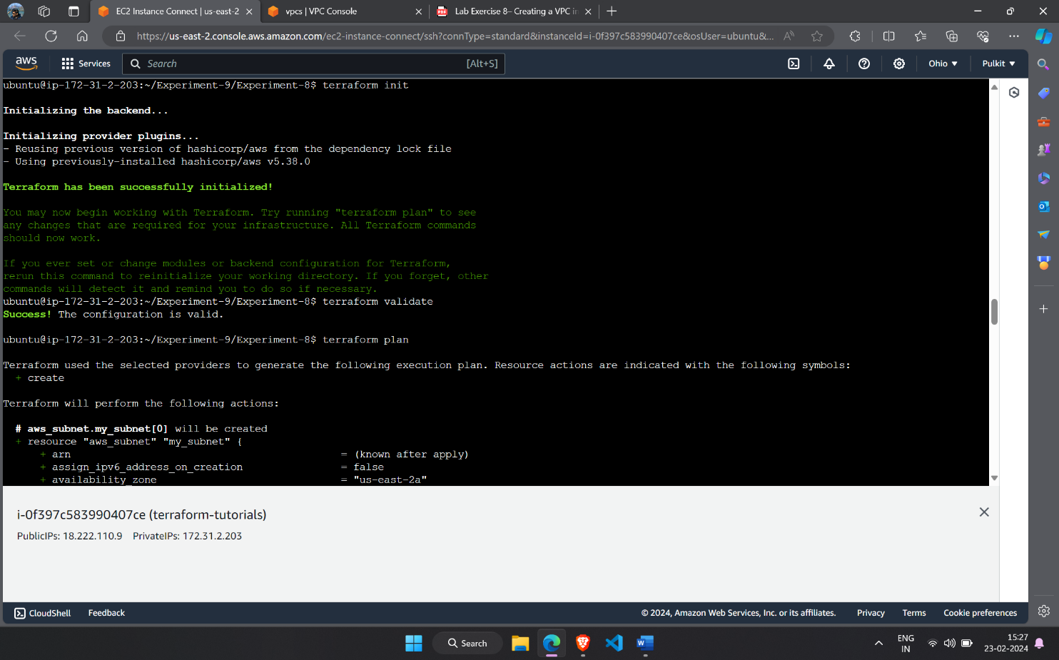

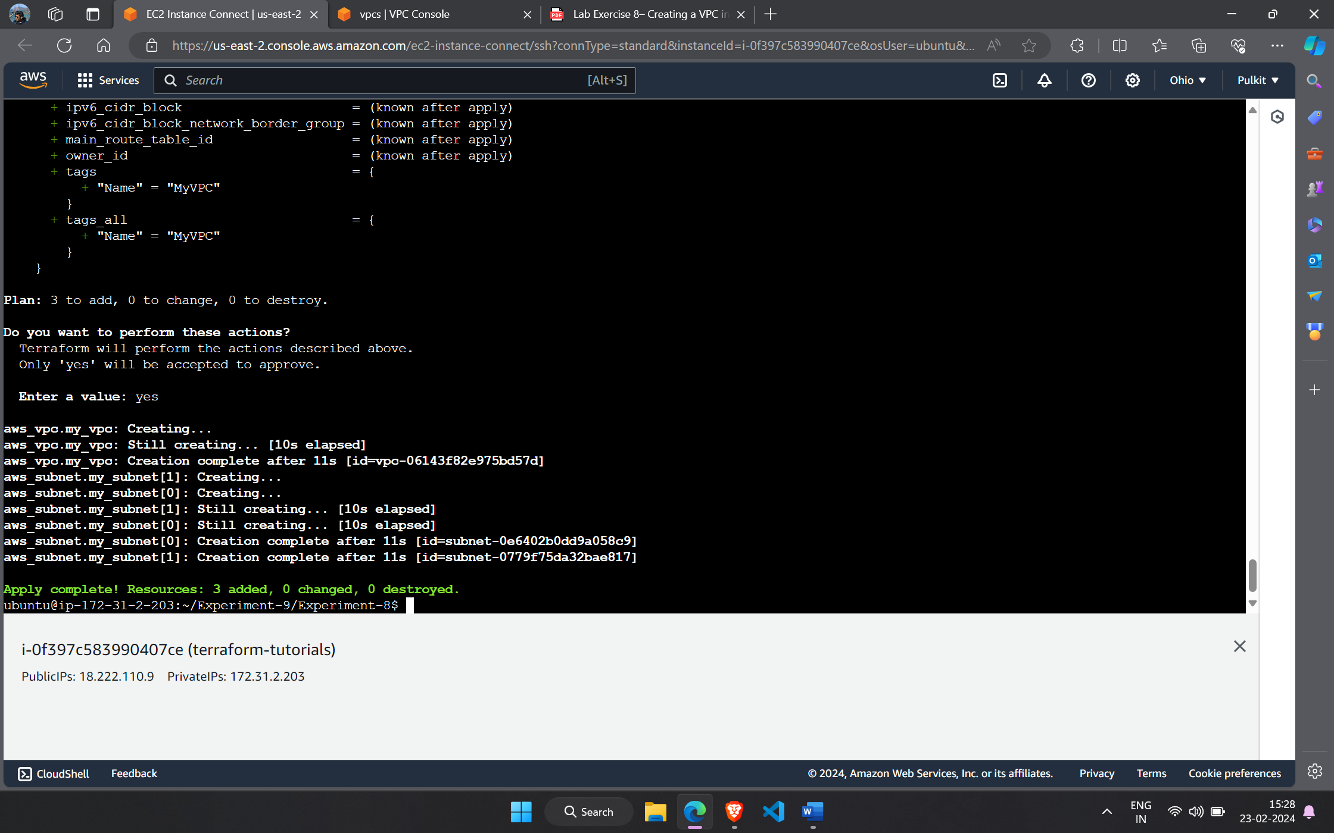

1. Verify the infrastructure.

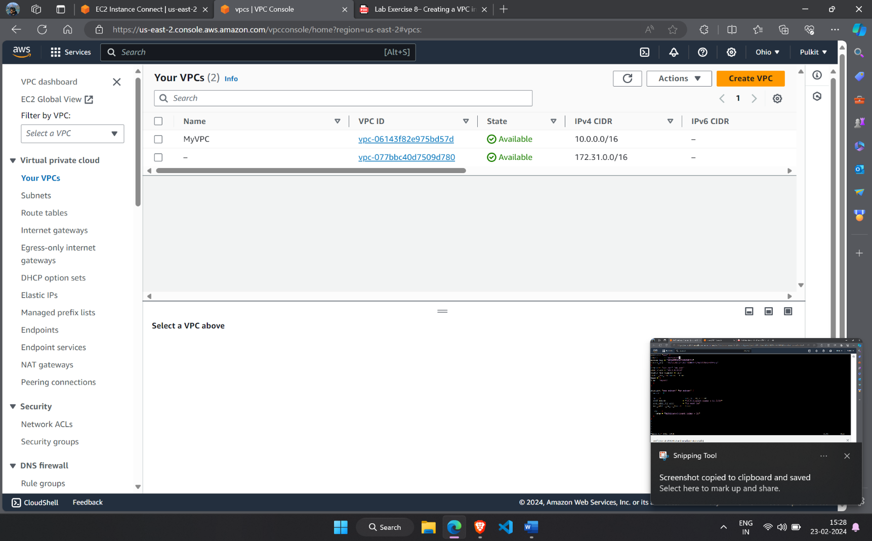

1. Destroy.

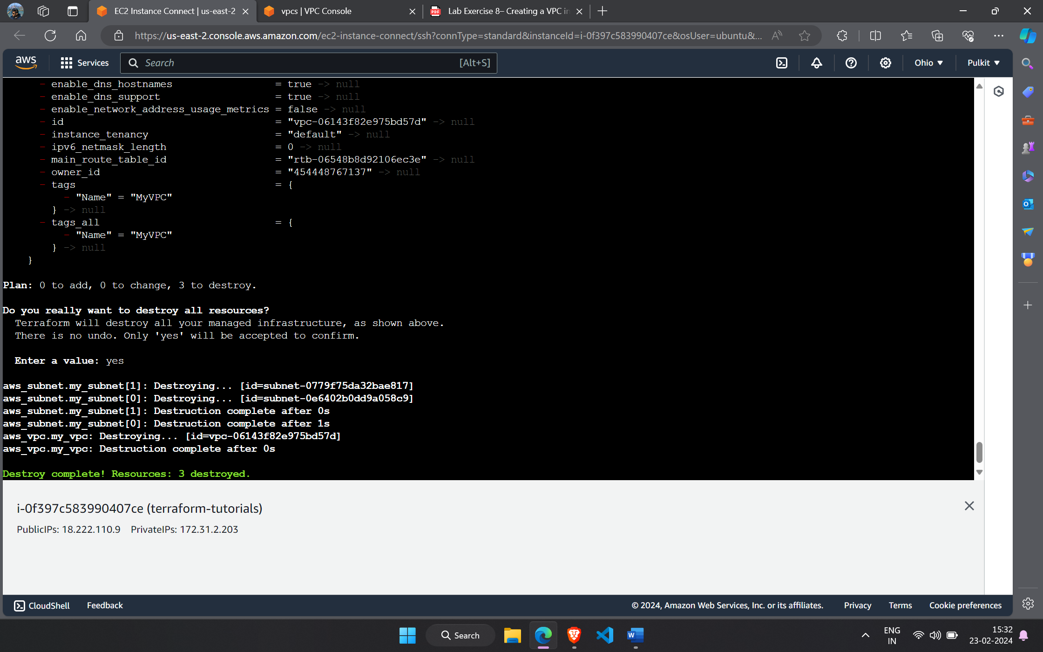

***Experiment-9***

1. Create a main.tf

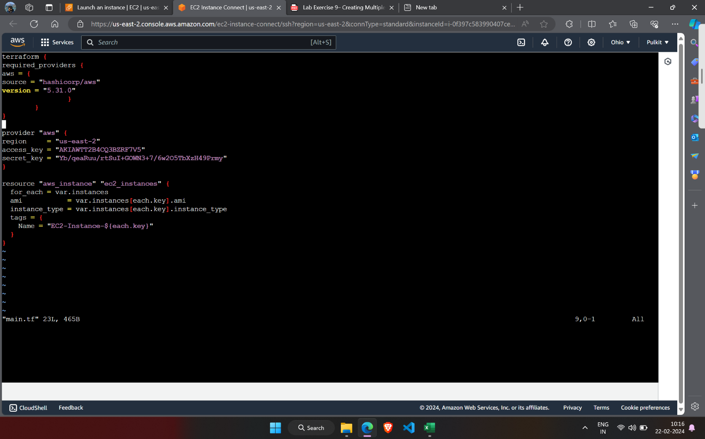

1. Create var.tf

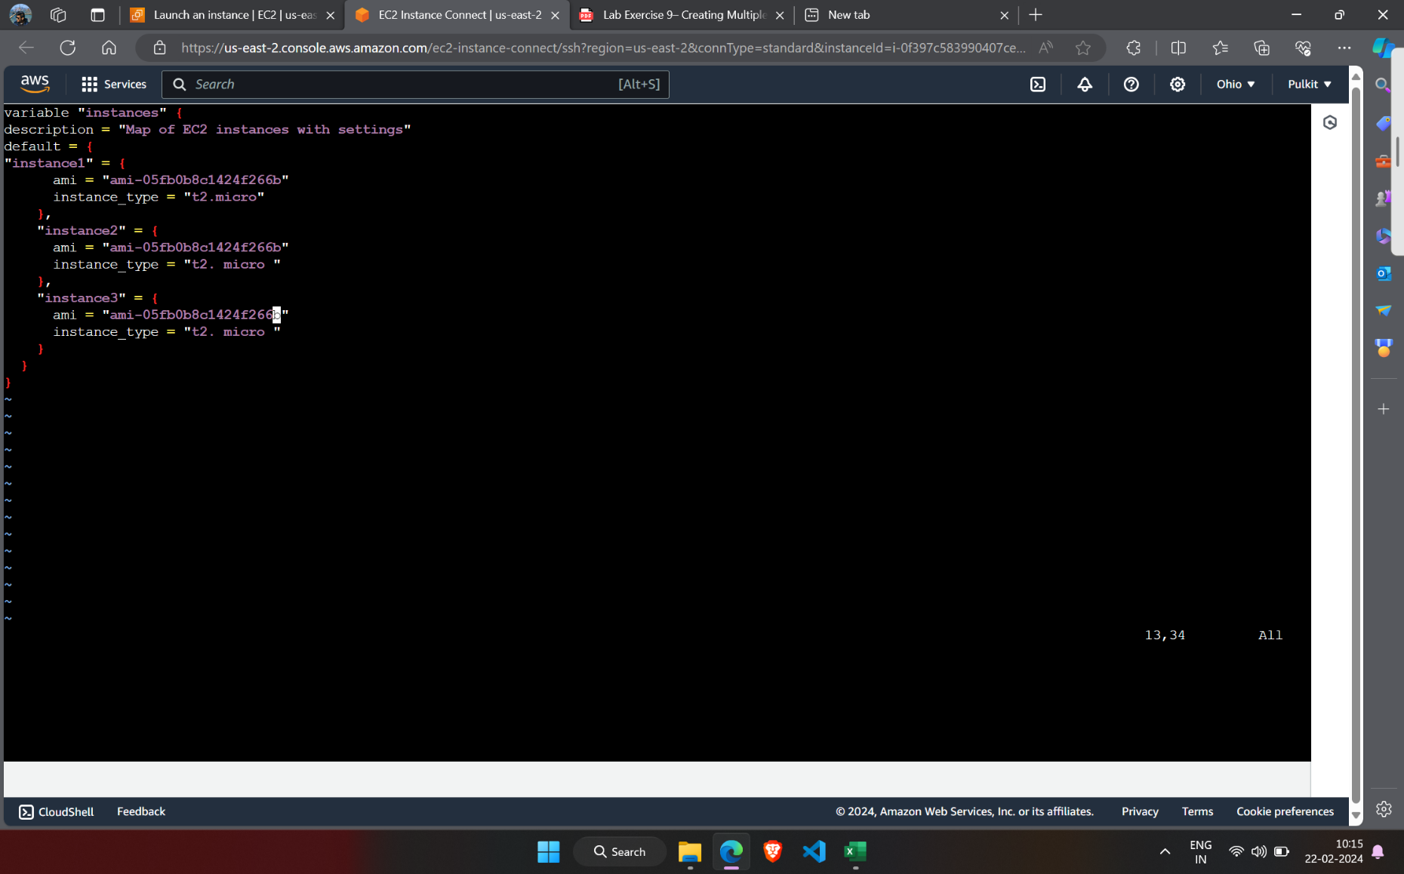

1. Terraform initialize, validate and apply.

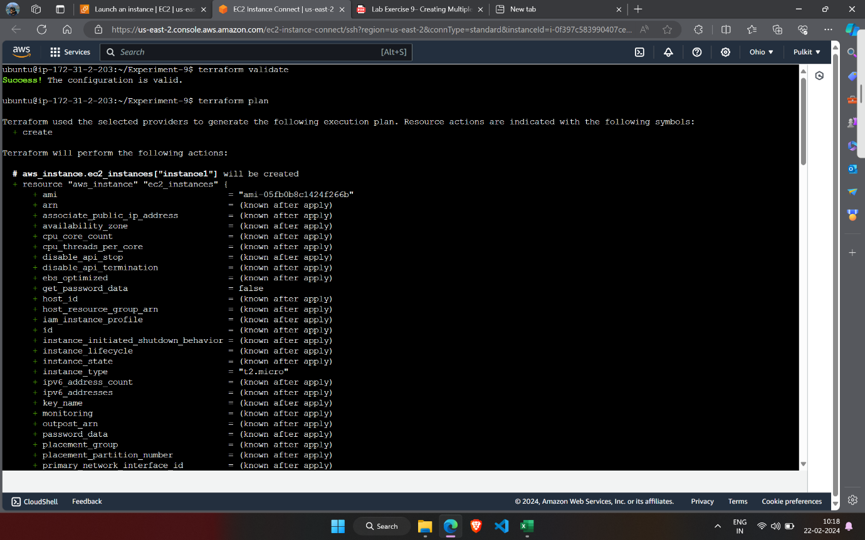

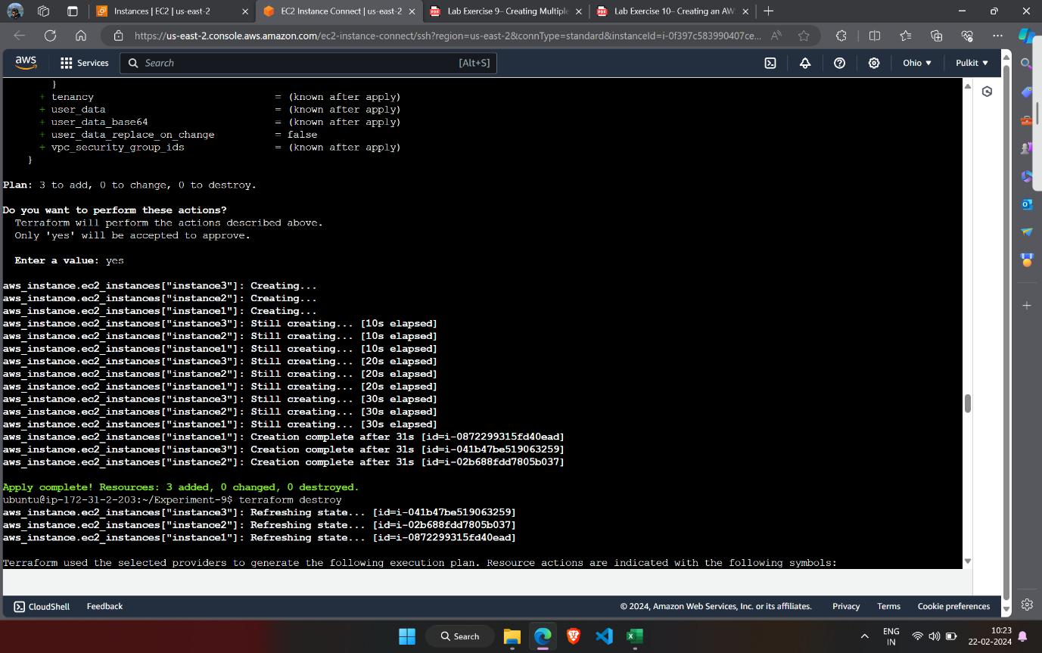

1. After terraform apply.

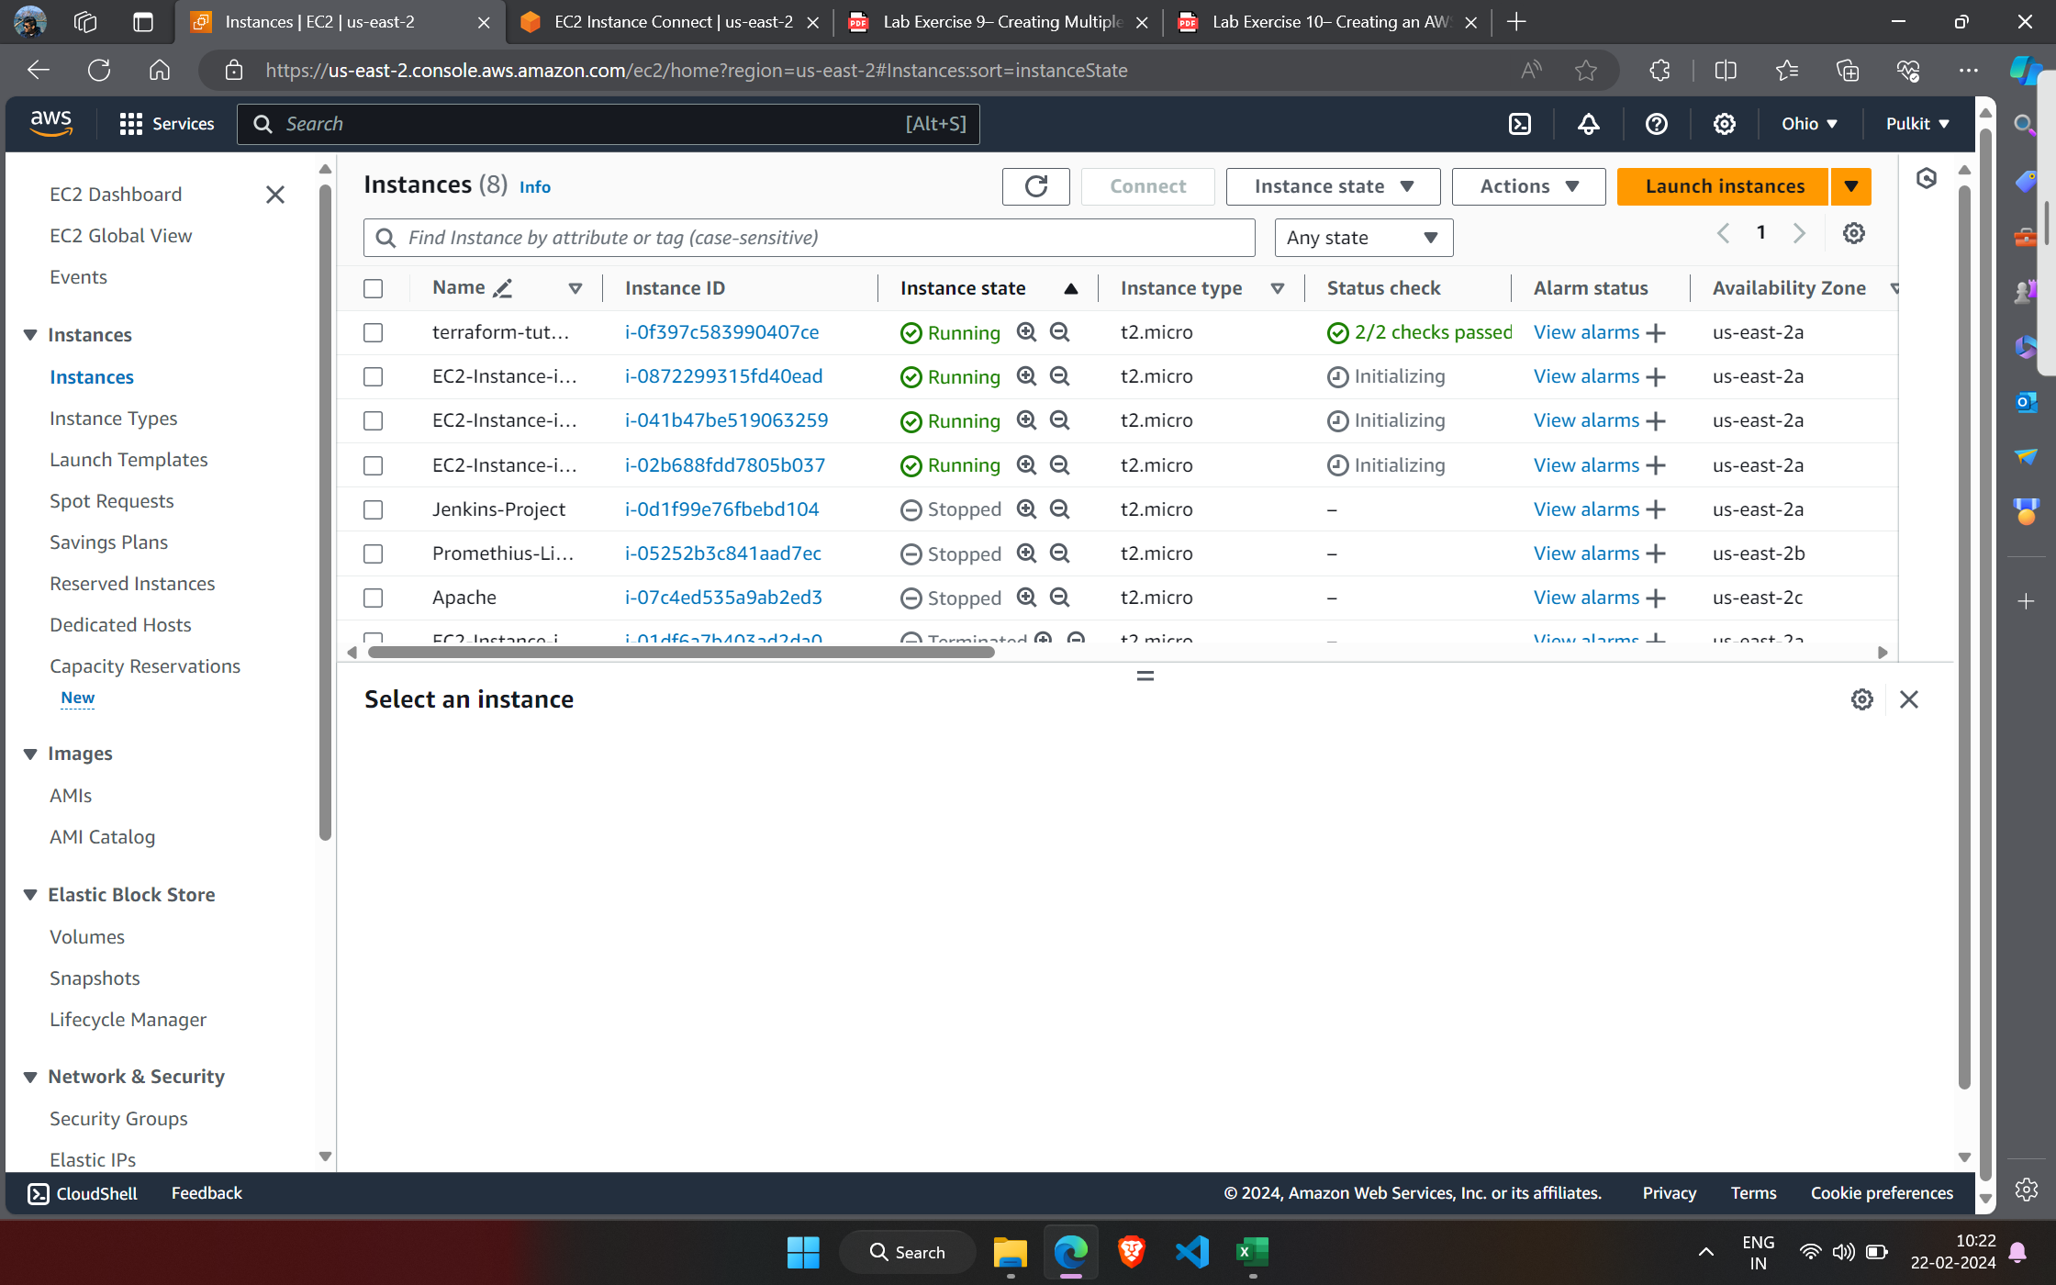

1. Destroy infrastructure.

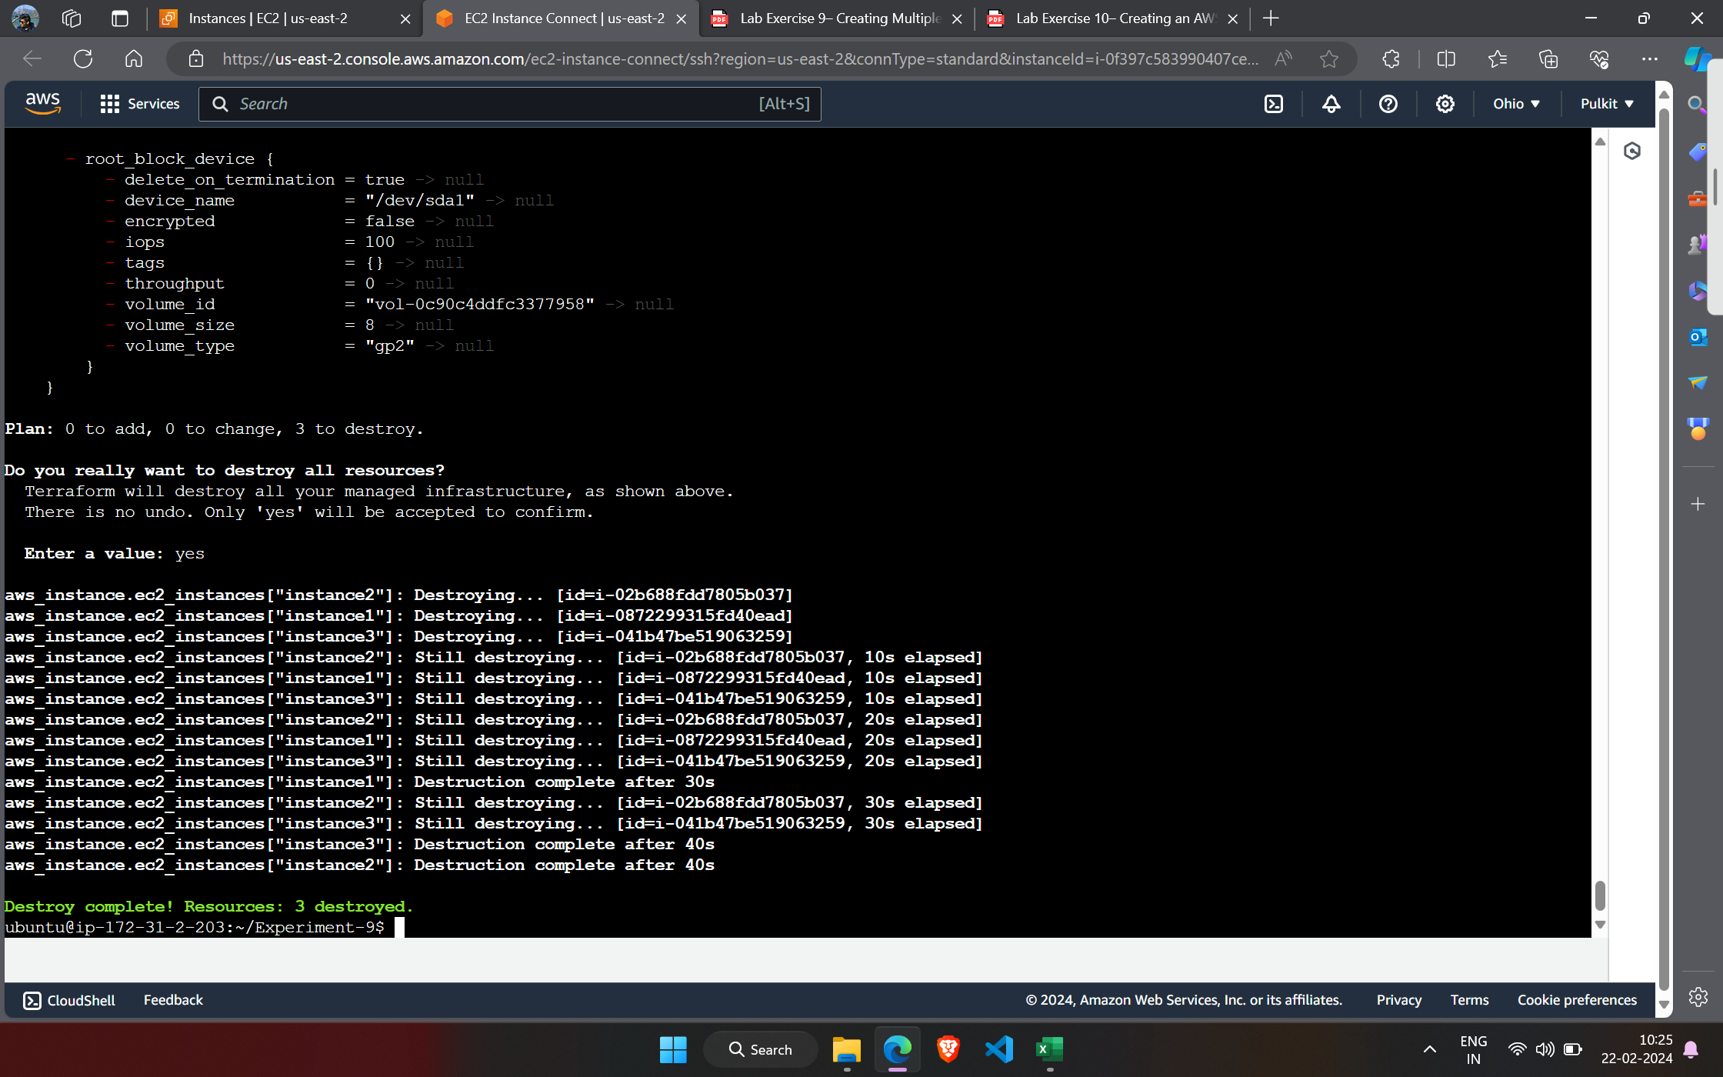

***Experiment-10***

1. Create main.tf

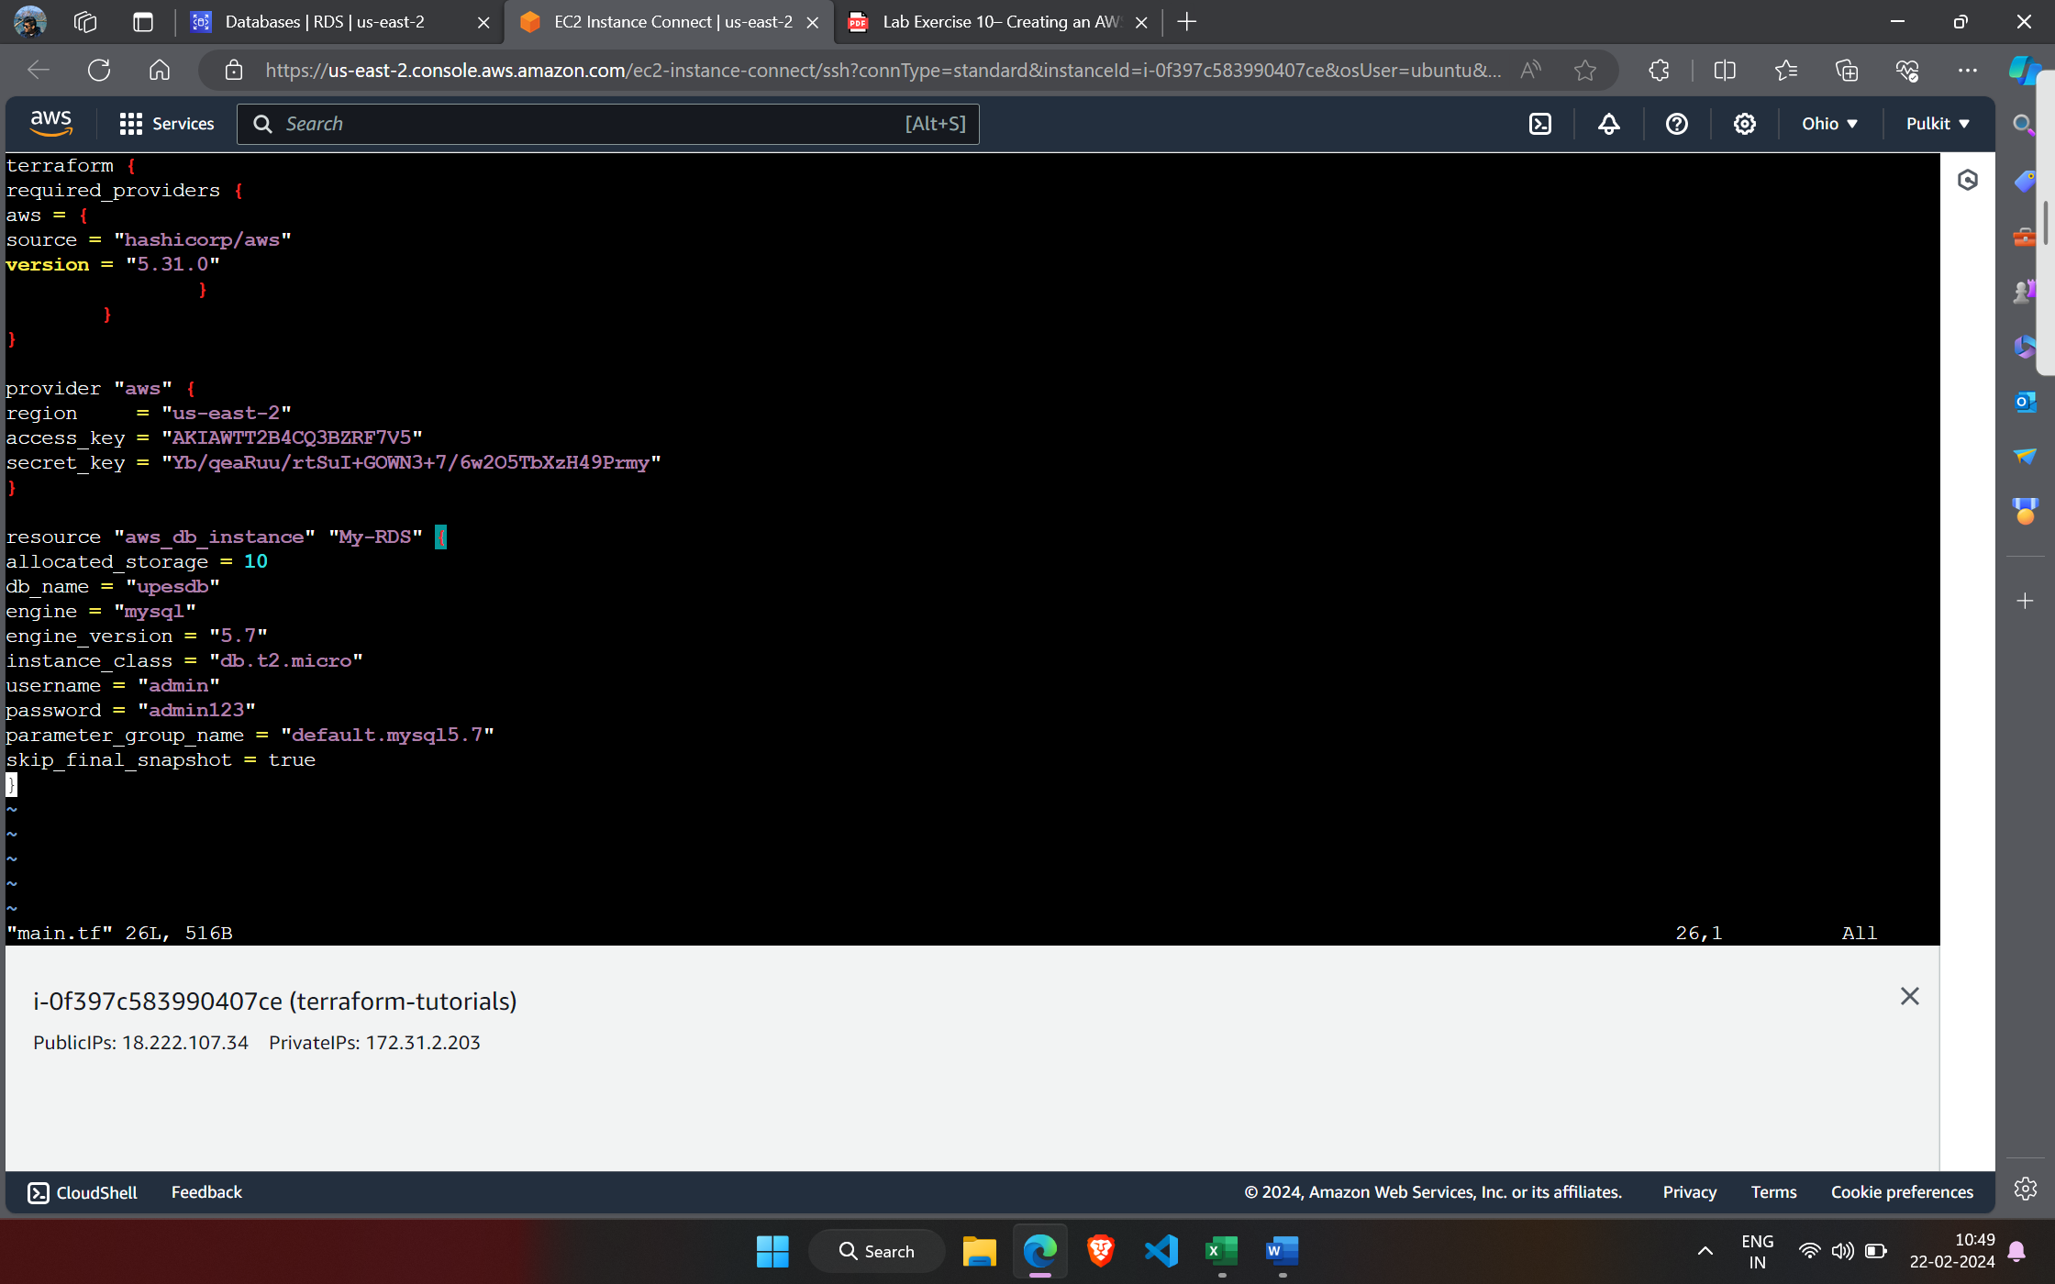

1. Terraform initialize, validate and apply.

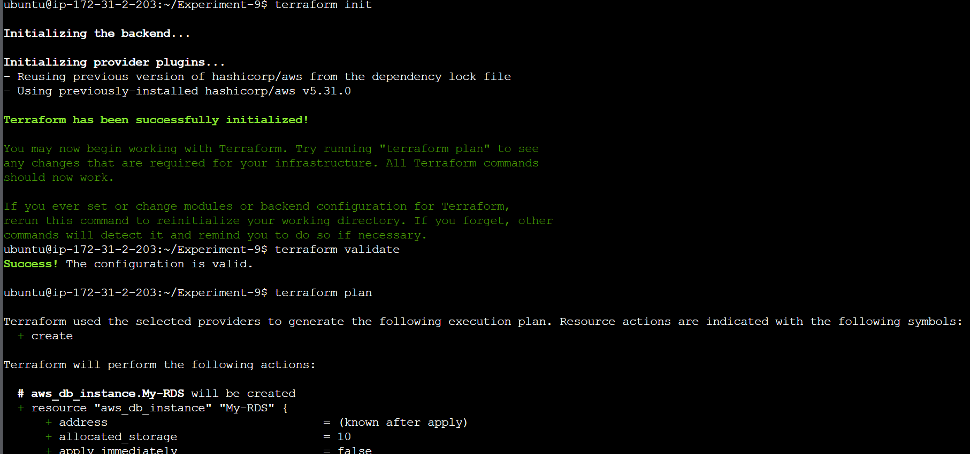

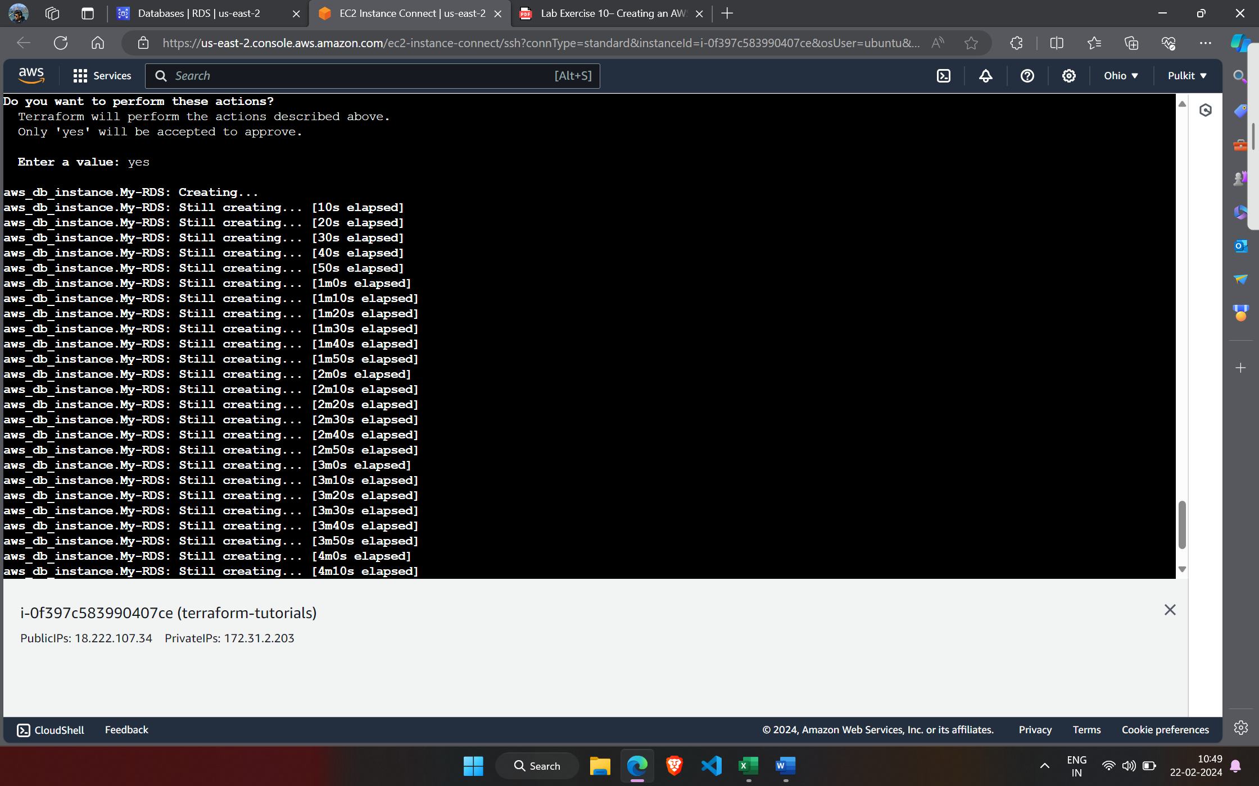

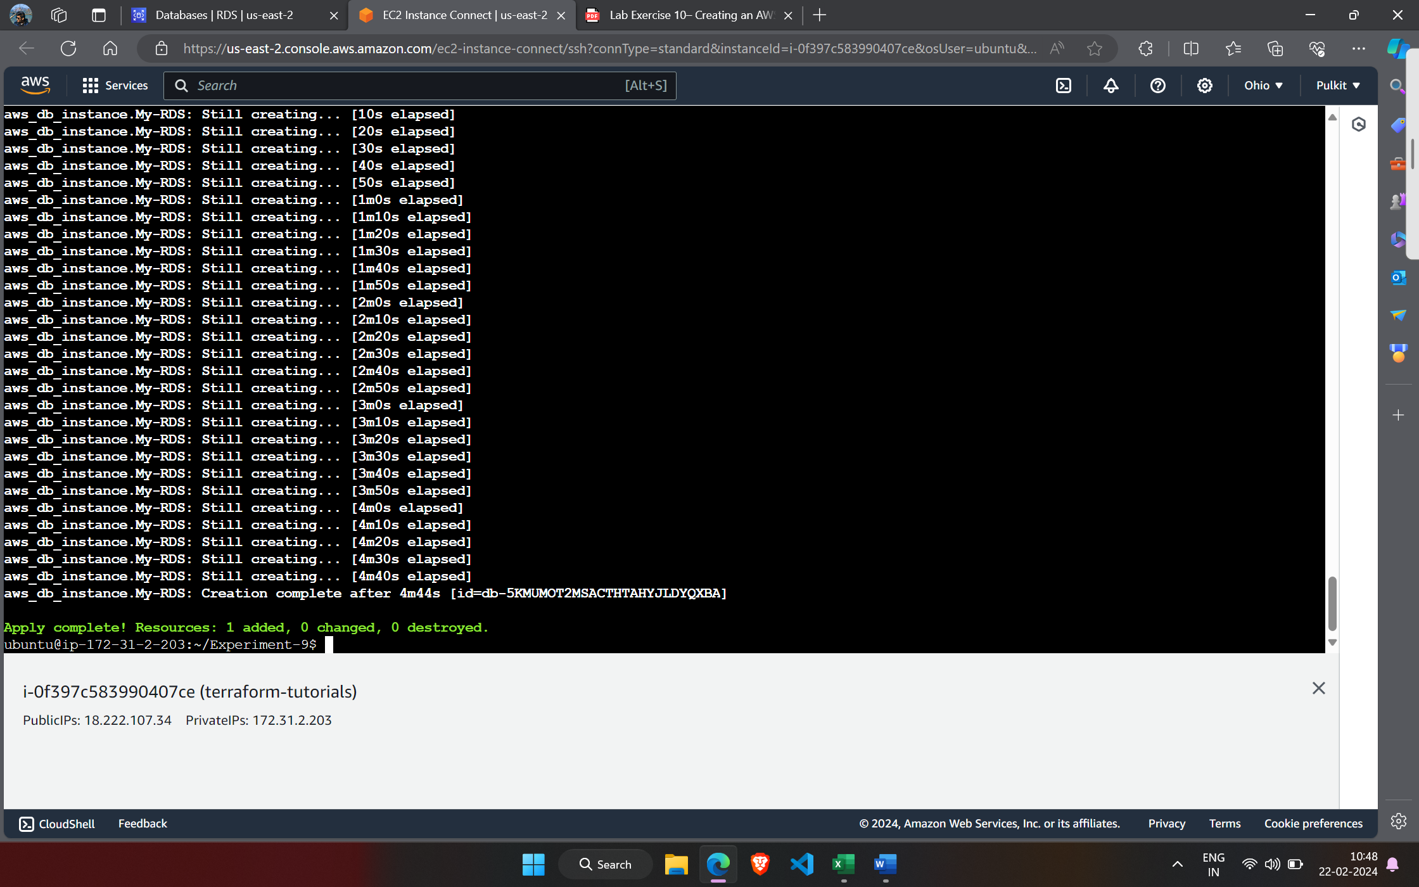

1. Verify the infrastructure.

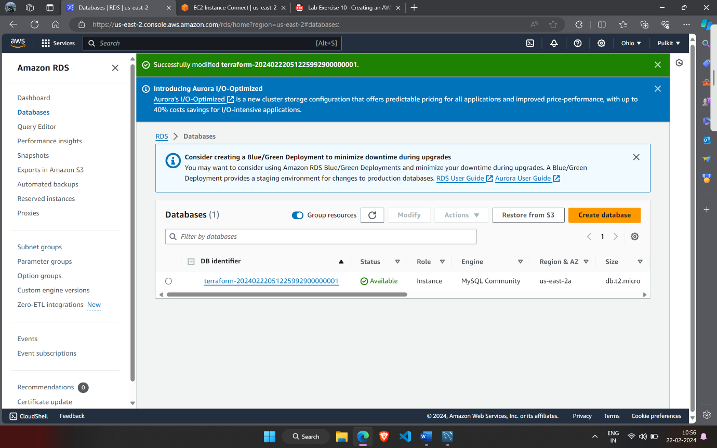

1. Destroy the infrastructure.

